**PERFORMANCE TESTING**

1. **PINGDOM TOOL**

(<https://tools.pingdom.com>)

* Grades your site out of 100.
* Uses YSlow and PageSpeed Insights.

**Pros:**

* Easy to use.
* The Full Page Test loads a complete HTML page. This testing includes images, CSS, JavaScript, RSS, iframes, etc.
* Multiple locations are considered during testing:
  + Dallas, Texas, USA
  + Melbourne, Australia
  + New York, USA
  + Stockholm, Sweden
* Can select “Sweden” as the location to test from
* Grouping of requested URLs and content size by domain
* Suggest different solutions to optimize
* Run analysis quite fast.
* Creates a waterfall chart of the results, to indicate different stages of a request (i.e. DNS, SSL, Connect, Send, Wait, and Receive)

**Cons:**

* It seems not possible to simulate the test on a portable device (mobile phone, tablet) and choose the browser
* Filmstrip View is not available
* To view detail for: Waterfall chart, Performance Grade, Page Analysis and History, user must paid.

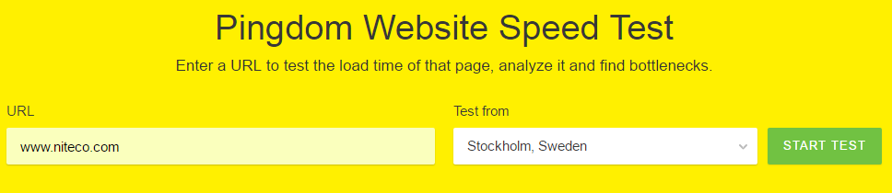

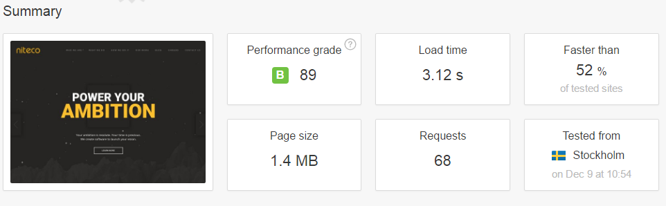

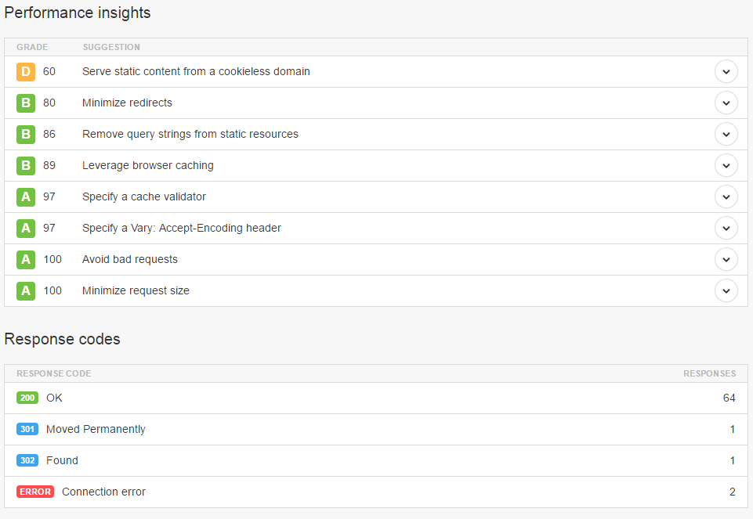

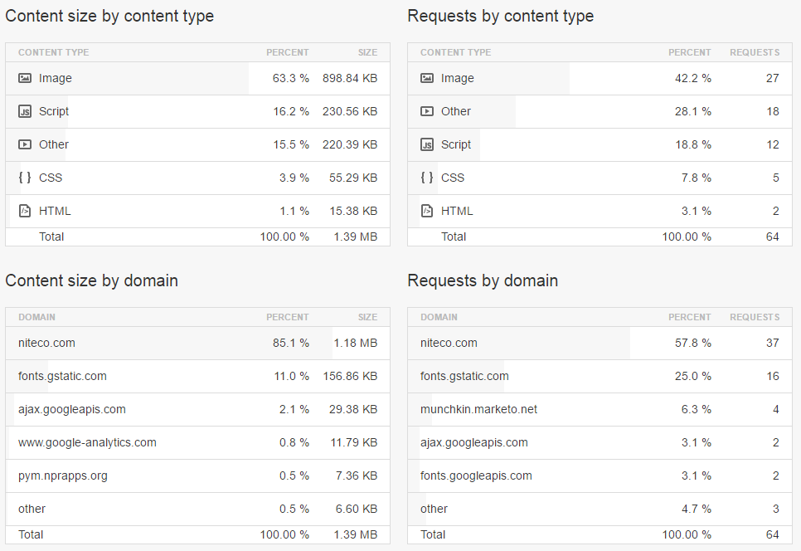

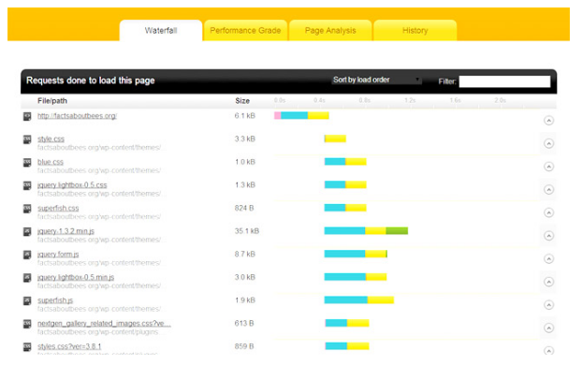

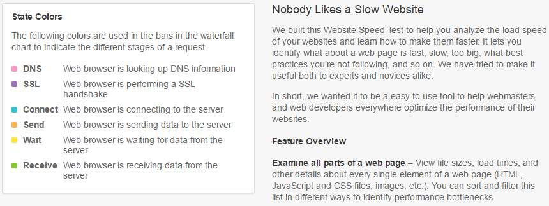

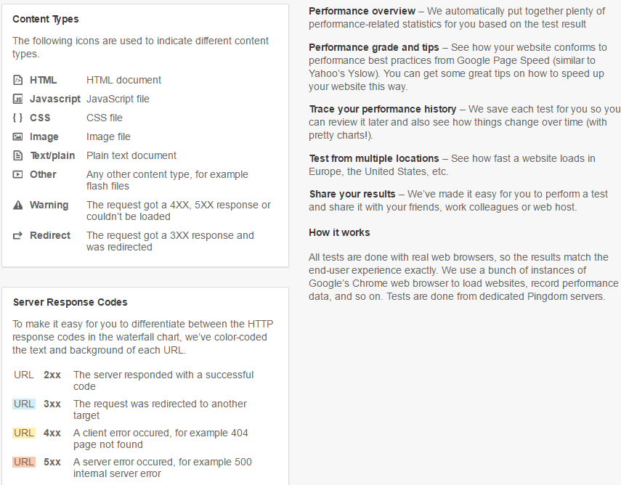

1. **WebPageTest**

(<https://www.webpagetest.org/>)

This is a multi-featured tool that offers the following:

* Generates screenshots to show how the page is performing at incremental intervals (e.g. using [filmstrip view](http://www.sitepoint.com/page-speed-soon-visitors-see-content/)).
* Creates a waterfall chart for content breakdown.
* Different content elements are represented by different colors.
* Allows multiple URLs to be compared.

**Pros**

* Easy to use & free
* Can choose different test locations & simulate different browsers
* Can simulate the test on a portable device (mobile phone, tablet)
* Provide the result of both First View and Repeat View (with Cache)
* Filmstrip View and Video are available
* Allow setting the type of connection: Cable, DSL, 2G, 3G, …
* Support advanced features such as video capture, disabling Javascript, ignoring SSL certificates, and spoofing user agent strings.

**Cons:**

* Cannot select “Sweden” as the location to test from, have to go with a city in Europe
* No suggestions to optimize the site

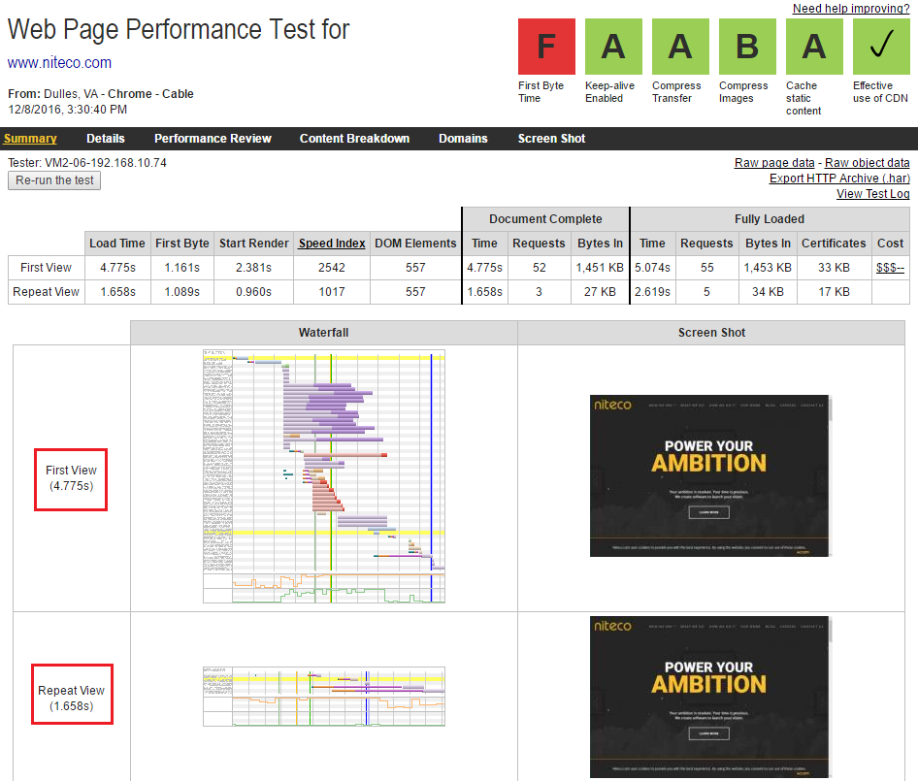

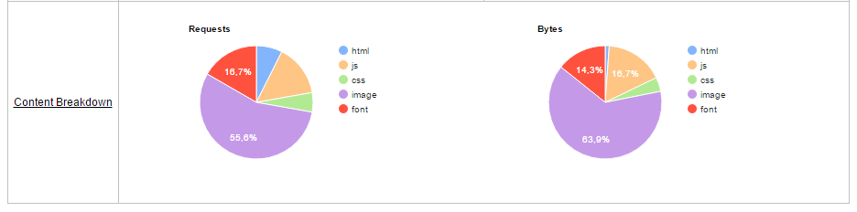

<https://sites.google.com/a/webpagetest.org/docs/using-webpagetest/quick-start-quide#TOC-Interpreting-the-Results>

**First View:**  
The First View row is a test that was done with a browser that had its cache and cookies cleared out and represents what a first-time visitor to the page will experience.

**Repeat View:**

The *Repeat View* row is a test that was done immediately after the First View test without clearing out anything.  The browser window is closed after the First View test and then a new browser is launched to do the Repeat View test.  The Repeat View test represents what someone will see if they are coming back to the page some time after visiting it the first time (and is a best-case scenario since the test is re-visiting the page immediately).

**Document Complete:**

The metrics grouped together under the *Document Complete* heading are the metrics collected up until the browser considered the page loaded (onLoad event for those familiar with the javascript events).  This usually happens after all of the images content have loaded but may not include content that is triggered by javascript execution.

**Fully Loaded:**

The metrics grouped together under the Fully Loaded heading are the metrics collected up until there was 2 seconds of no network activity after Document Complete.  This will usually include any activity that is triggered by javascript after the main page loads.

**Load Time:**

The Load Time is the time from when the user started navigating to the page until the Document Complete event (usually when all of the page content has loaded).

**First Byte:**

The First Byte time is the time from when the user started navigating to the page until the first bit of the server response arrived.  The bulk of this time is usually referred to the "back-end time" and is the amount of time the server spent building the page for the user.

**Start Render:**

The Start Render time is the first point in time that something was displayed to the screen.  Before this point in time the user was staring at a blank page.  This does not necessarily mean the user saw the page content, it could just be something as simple as a background color but it is the first indication of something happening for the user.

**DOM Elements:**

The DOM Elements metric is the count of the DOM elements on the tested page as measured at the end of the test.

**Requests:**

This is the number of requests that had to be made by the browser for pieces of content on the page (images, javascript, css, etc).

**Bytes In:**

This is the amount of data that the browser had to download in order to load the page.  It is also commonly referred to as the "Page Size".

1. **GTMetrix**

Gives the full picture on how your site loads and helps you detect where bottlenecks are.

Key features include:

* [PageSpeed and YSlow scores](https://gtmetrix.com/) and [Recommendations](https://gtmetrix.com/)
* [Page Load Details](https://gtmetrix.com/) (time, size, number of requests)
* [Various Analysis Options](https://gtmetrix.com/)
* [Waterfall, Video and Report History](https://gtmetrix.com/)

**Pros**

* Easy to use
* Suggest different solutions to optimize
* Have comparison allow compare between 2 different urls
* Support analyze your page on an actual Android device.

**Cons**

* Cannot choose test server location and browser to test, only 1 location: Vancouver, Canada & using Firefox browser without register and support 7 regions with register.
* Only support analyze on an actual Android device at Vancouver region

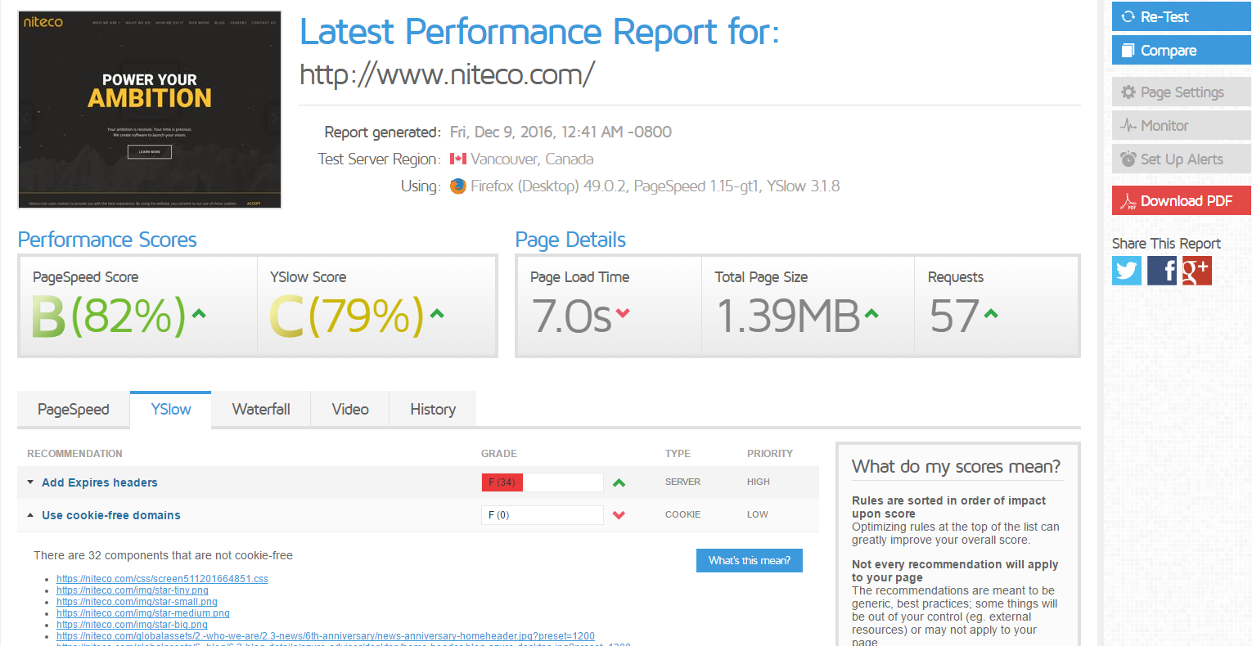

**Reference:**

* 1. [**https://www.sitepoint.com/tools-testing-website-performance/**](https://www.sitepoint.com/tools-testing-website-performance/)
  2. [**https://creativeoverflow.net/20-tools-to-check-your-web-sites-performance/**](https://creativeoverflow.net/20-tools-to-check-your-web-sites-performance/)